FAST NATIONAL UNIVERSITY OF COMPUTING AND EMERGING SCIENCES



SSD PROJECT FINAL REPORT
K214771 Mehdi Badami

LECTURER:
Sir Abuzar Zafar

PROJECT TITLE:
Securing The Car Pool System with zero knowledge proof

Table of Contents
Abstract 2
Introduction 3
Objectives 3
System Architecture 3
Implementation Details 3
1. User Authentication and Session Management 3
2. Input Validation and SQL Injection Prevention 4
3. CSRF Protection 4
4. Encryption 4
5. Logging and Monitoring 4
Threat Modeling 4
1. Threat Model Overview 4
Diagram 6
2. UML Diagrams 7
Risk Assessment 8
Results 8
Conclusion and Future Work 9
References 9
Appendix 9
A. Code Snippets 9
B. Tools and Technologies Used 9
C. Abbreviations 9

Abstract
This project focuses on enhancing the security of a ride-sharing system—CarPool App—to address common vulnerabilities and ensure robust protection for its users. The implementation includes user authentication, secure session management, encryption, CSRF protection, input validation, and SQL injection prevention. The project also develops a threat model, UML diagrams with misuse cases, and a comprehensive risk assessment to identify and mitigate potential security risks.

Introduction
With the rise of ride-sharing platforms, securing sensitive user data and ensuring safe transactions have become critical. This project aims to strengthen the security of a carpooling application by addressing known vulnerabilities and implementing secure software practices. The system is built using Flask and SQLite (scalable to MySQL/PostgreSQL) and employs modern security techniques to protect against attacks such as session hijacking, SQL injection, and CSRF.

Objectives
- To identify and mitigate common vulnerabilities in web applications reflecting from OWASP TOP 10.
- To implement secure coding practices for authentication, session management, and input validation.
- To create a threat model and UML diagrams to visualize misuse cases.
- To conduct a risk assessment and propose mitigation strategies.

System Architecture
The CarPool App consists of three primary components:
- User Module: Handles user authentication and role management (passenger, driver, admin).
- Ride Management Module: Manages passenger requests and driver offers.
- Admin Dashboard: Enables monitoring and management of the platform.
The backend is implemented using Flask, with SQLite as the database for development and PostgreSQL as an optional production database.

Implementation Details

1. User Authentication and Session Management
- Session Management:
  - Implemented secure session cookies with Flask’s session module.
  - Set cookies with HttpOnly and Secure flags to prevent XSS and MITM attacks.
  - Enforced session expiration after inactivity.
- Authentication:
  - Hashed passwords using SHA-256 with a unique salt.
  - Implemented account lockout after multiple failed login attempts.

2. Input Validation and SQL Injection Prevention
- Used Flask’s request.form and validation libraries to sanitize inputs.
- Used parameterized queries for all database operations to prevent SQL injection.

3. CSRF Protection
- Enabled CSRF tokens in all forms and API requests using Flask-WTF.

4. Encryption
- Secured sensitive data using custom encryption and traditional ones md5.
- Encrypted communication with HTTPS using an SSL certificate.

5. Logging and Monitoring
- Implemented logging using Python’s logging module with RotatingFileHandler for secure log management.
- Set up alerts for suspicious activities such as unusual login attempts.

Threat Modeling

1. Threat Model Overview
The Thread model in my case was STIDE to Implement so I add Stride in it
Threat | Description | Mitigation
Spoofing | An attacker impersonates a legitimate user (e.g., passenger or driver) by gaining access to their credentials. | - Implement strong password policies (complex passwords, 2FA).
 |  | - Use secure authentication mechanisms (OAuth, JWT).
 |  | - Monitor suspicious login attempts and access patterns.
Tampering | An attacker alters data in transit or the database (e.g., modifying ride details, pricing, or user data). | - Use encryption (TLS) for data in transit.
 |  | - Implement database encryption and secure access controls.
 |  | - Regularly validate data integrity with hashes or checksums.
Repudiation | A user denies performing an action (e.g., driver denies accepting a ride). | - Log all important actions with timestamps and user identifiers.
 |  | - Provide clear audit trails for transaction-related actions.
 |  | - Ensure logs are immutable and protected from tampering.
Information Disclosure | Sensitive data (e.g., user details, location) is exposed to unauthorized parties. | - Use encryption at rest and in transit.
 |  | - Limit data exposure to authorized users only (e.g., show partial phone numbers).
 |  | - Anonymize or pseudonymize sensitive data.
Denial of Service (DoS) | An attacker overwhelms the system with fake requests or traffic, making it unavailable to legitimate users. | - Implement rate-limiting and traffic filtering (IP blocking, CAPTCHA).
 |  | - Use DDoS protection services (e.g., Cloudflare, AWS Shield).
 |  | - Monitor for unusual traffic patterns and adjust thresholds.
Elevation of Privilege | A user gains higher privileges (e.g., passenger accesses the admin interface or driver manipulates payments). | - Implement role-based access control (RBAC).
 |  | - Regularly review and update user roles and permissions.
 |  | - Apply least privilege principles to minimize escalation impact.

- Assets: User credentials, payment information, ride data.
- Threat Actors: Hackers, malicious insiders, compromised third-party APIs.
- Attack Vectors: SQL injection, XSS, session hijacking, CSRF.

Diagram
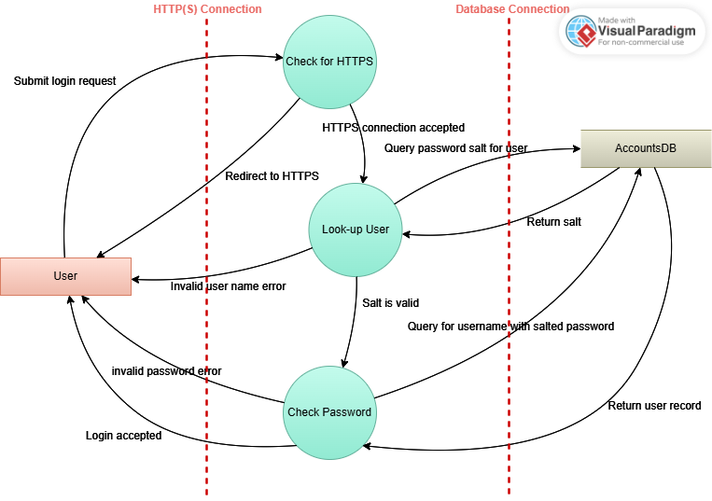

2. UML Diagrams
- Use Case Diagram: Illustrates the primary user interactions with the system.
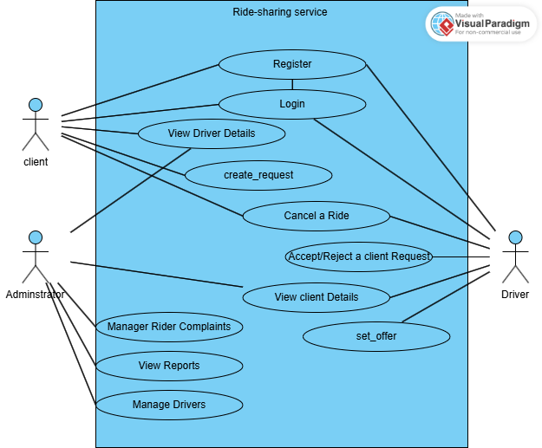
- Misuse Case Diagram: Highlights potential misuse scenarios and countermeasures.
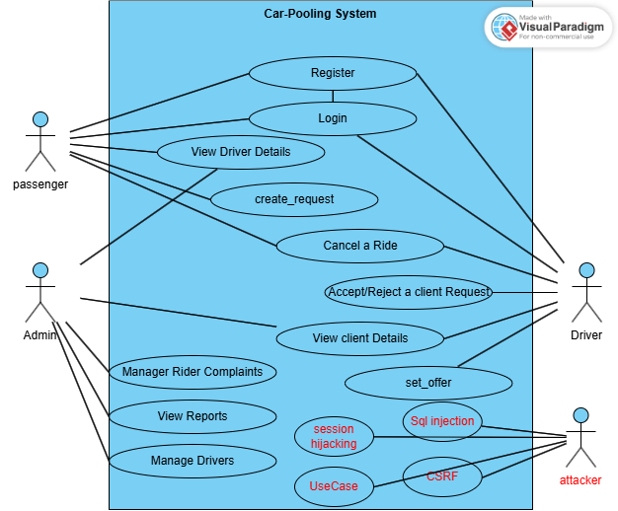

Risk Assessment
Risk Assessment
Risk | Likelihood | Impact | Mitigation
SQL Injection | High | High | Use parameterized queries and input validation
Session Hijacking | Medium | High | Use secure, unpredictable session IDs
CSRF Attacks | Medium | Medium | Implement CSRF tokens
Data Breaches | Low | High | Encrypt sensitive data and enforce HTTPS

Results
- Successfully secured the application against SQL injection and CSRF.
- Enhanced session security by using secure cookies and enforcing expiration.
- Reduced risk of XSS through input validation and HttpOnly cookies.

Conclusion and Future Work
The CarPool App security enhancements effectively address common web application vulnerabilities. Future work includes:
- Implementing multi-factor authentication (MFA).
- Conducting penetration testing for further validation.
- Automating security monitoring using AI-based tools.

References
- Flask Documentation: https://flask.palletsprojects.com/
- OWASP Top 10: https://owasp.org/www-project-top-ten/
- SQLite Security Best Practices: https://sqlite.org/security.html
- Thread Modeling Visual Paradigm - Online Productivity Suite

Appendix

A. Code Snippets
- Example of Parameterized Query:
cursor.execute("SELECT * FROM users WHERE username = ?", (username,))
- CSRF Token Implementation:
from flask_wtf.csrf import CSRFProtect
csrf = CSRFProtect(app)

B. Tools and Technologies Used
- Flask Framework
- SQLite/PostgreSQL
- Python Logging Module
- Flask-WTF for CSRF Protection
- MD5 Encryption

C. Abbreviations
- XSS: Cross-Site Scripting
- CSRF: Cross-Site Request Forgery
- MFA: Multi-Factor Authentication
- MITM: Man-In-The-Middle Attack

